**CIT 117 Unix/Linux Lab Four**

**Name:____________________________________________ Date:__________________________**

***Filesystems***

**Objectives:**

* **Understand basic Linux filesystem commands**
* **Mounting and unmounting filesystems**
* **Checking filesystems with fsck**

**If using virtualbox start here else go to vsphere!**

Start creating a new instance as from lab 2 or three. Before booting your instance. Add Three extra disk drives to your VM. See instructions below.

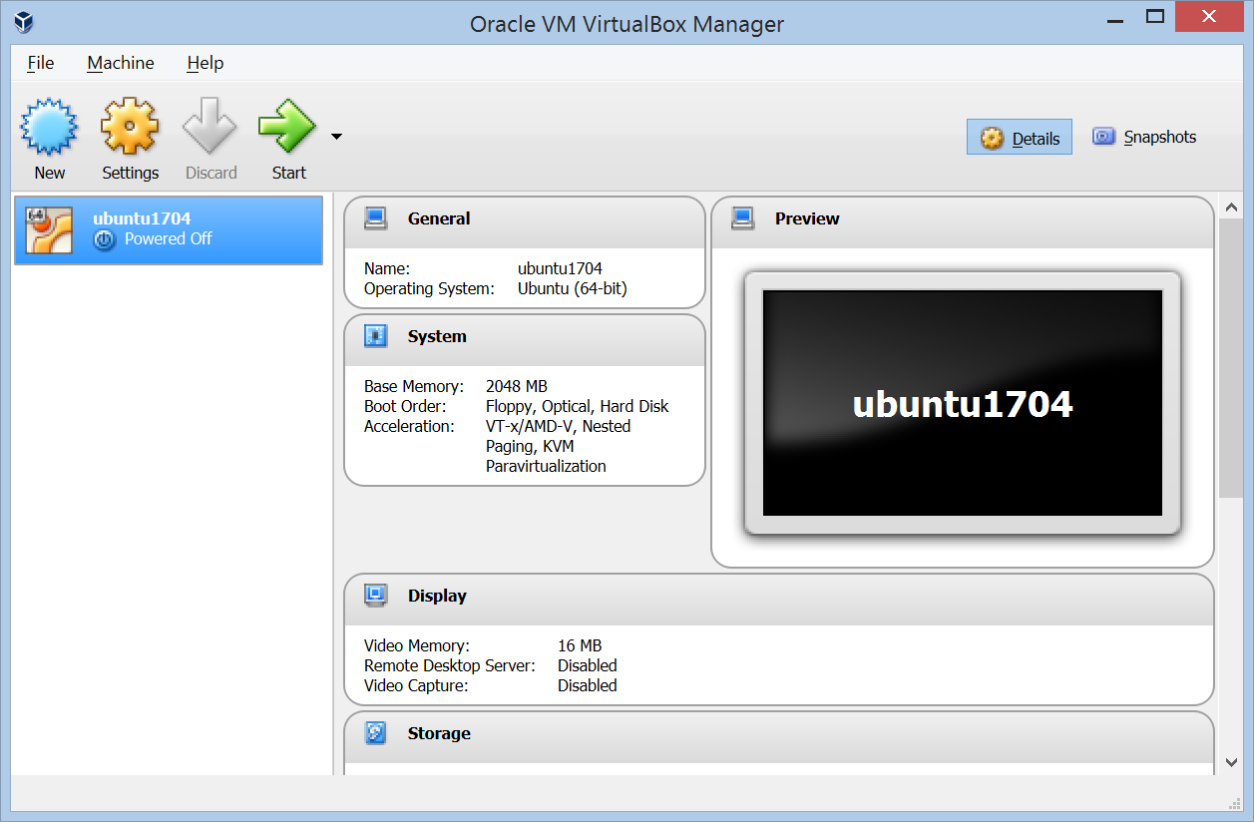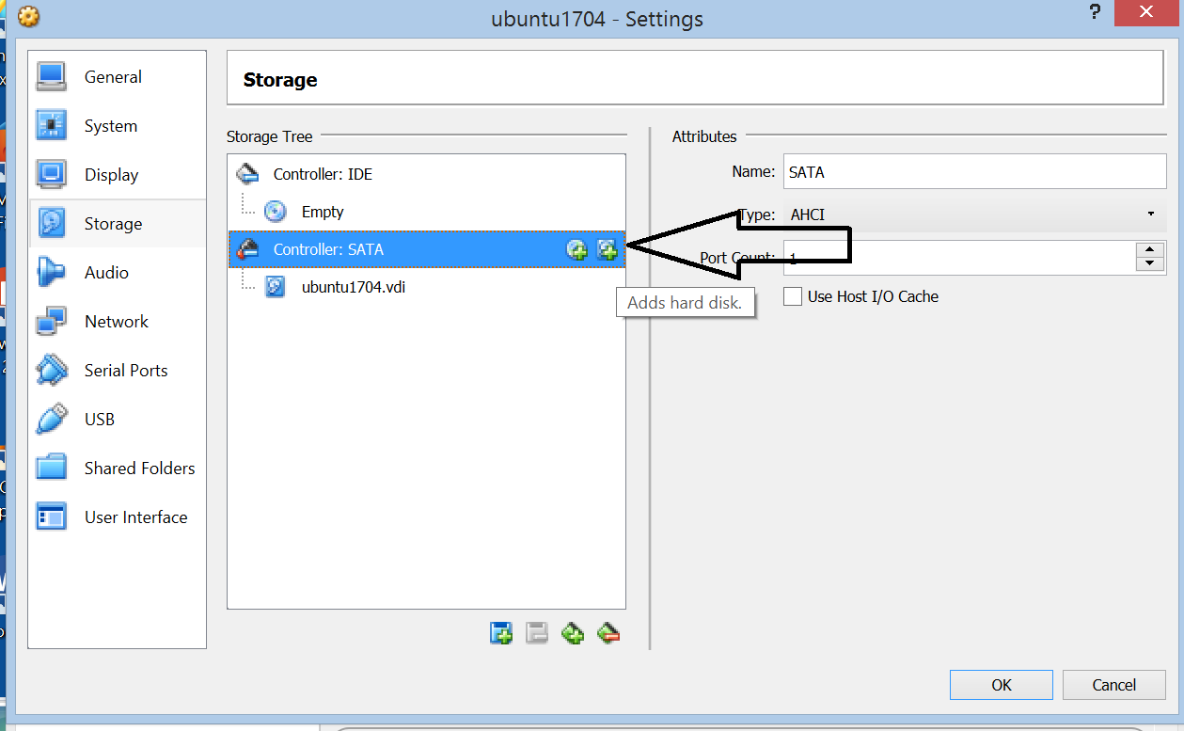

In settings Storage Controller SATA click the add hard disk icon.

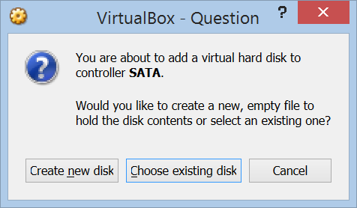

Choose create new disk.

Create a new disk. Name it Disk1 and allocate 5 gigabytes.

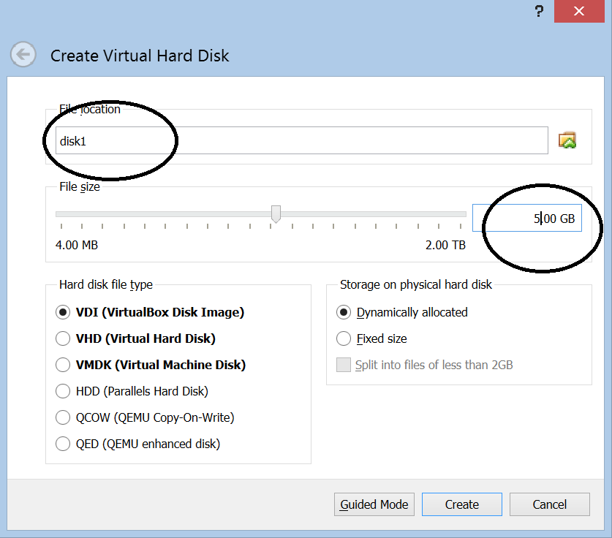

Then create 2 more disks. Disk2 and Disk3

Your storage Window should look like this when done adding disks.

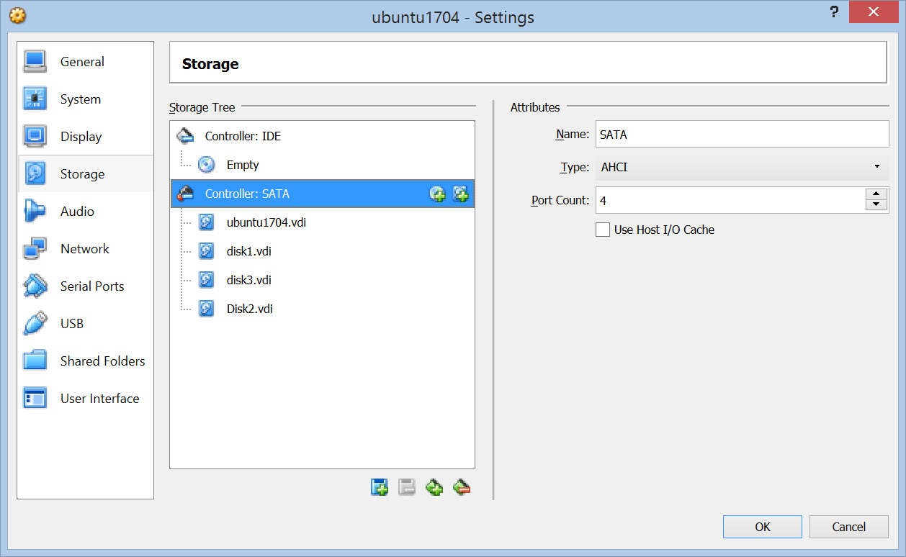

Click Ok and start your machine.

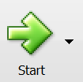

**If using vsphere start here!**

Select your ubuntu20 instance and make sure it is powered down.

Select 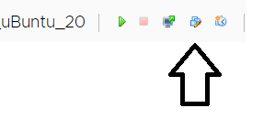 Edit settings.

Select add new device:

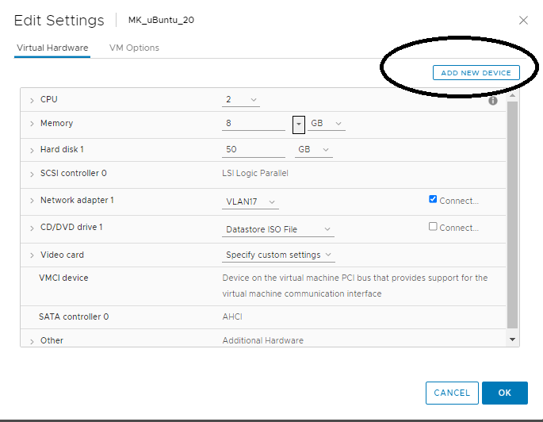

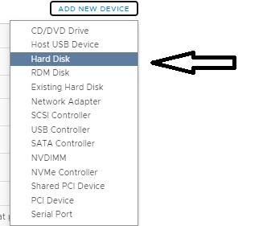Select hard drive.

Create a new one(1) gig hard drive



Select Thin provisioning.

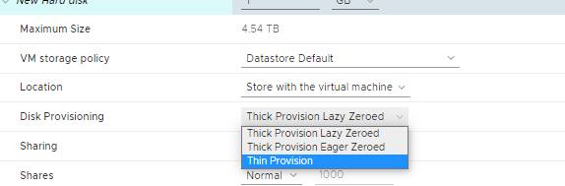

Click OK 

Start your ubuntu instance.

1) Log in to your virtual machine and open a terminal. At the command prompt, issue the command:

ls -l /dev/sd*

List and annotate the output of this command below, noting how many devices there are, and how many partitions each one has.

2) At the command prompt, issue the command:

mount

How many of the above partitions are mounted? Where are they mounted?

3) Issue the command:

less /etc/fstab

What partitions are being used by the system?

4). Type the command:

dmesg | less

Search for the string “sdb” in the output. What do you find there? What does it mean?

***Create partitions on our virtual SCSI disks.***

4) Type the command:

sudo fdisk /dev/sdb

You may be prompted for your password. At the “Command (m for help): “ prompt, type “m” and press enter. What happens?

5) Print the partition table for this disk. How did you go about this?

[Note: If you currently have a partition on sdb, type ***d*** to delete it!]

6) What partitions are on the disk?

7). Create a new Primary Partition on this Disk, using the entire 5 Gig available on the disk. Create it as primary partition number 1. How did you go about this?

8) Print the partition table for this disk again. Give the partition information below:

9) Write the new partition table to disk and exit fdisk. How did you go about this?

10) At the command prompt of your virtual machine, again type the command:

ls -l /dev/sd*

What is the output of this command? How does it differ from the previous times you ran this command? Why?

11) Issue the command:

sudo mkfs.ext4 /dev/sdb1

What is the output of this command?

What did this command do? [Hint: use the man pages!]

12) Create a mount point for the new volume by typing the command:

sudo mkdir /mnt/vol

Take a listing of the /mnt/vol directory. What files are found there?

13) Issue the command

mount

And examine the results

14) Mount the new filesystem on the directory we created by issuing the command:

sudo mount –t ext4 /dev/sdb1 /mnt/vol

Take a listing of the /mnt/vol directory. What files are found there?

15) Again issue the command

mount

What has changed since the previous time you ran this command?

16) Use the man pages to research the df command. What is the function of this command?

17) Issue the command:

df -h

Discuss the output of this command relative to our new volume. What is the size of our new volume?

18) At the command prompt, issue the command:

man fsck

Describe the function and operation of the fsck command:

19) At the command prompt, issue the command:

sudo fsck /dev/sdb1

What is the output of this command?

Click ***n*** to stop the file system check.

20) Unmount the new volume by issuing the command:

sudo umount /mnt/vol

21) Again issue the command:

mount

Is our volume still mounted?

22) Again issue the command:

sudo fsck /dev/sdb1

What is the output of this command?

23) At the prompt, issue the command:

man fstab

Describe the contents and function of the fstab file.

24) Examine /etc/fstab file. List some of its contents below and describe its format.

25) Edit the /etc/fstab file (you will need to have administrative access to do this), and add the following line:

/dev/sdb1 /mnt/vol ext4 errors=remount-ro 0 0

Save the file and reboot your machine by issuing the command:

**sudo shutdown -r now**

26) After your machine reboots, again issue the command:

mount

Is /mnt/vol mounted? Why did it automatically mount?

27) Issue the command:

cd /mnt/vol

28) Issue the command:

sudo umount /mnt/vol

What happens?

29) Find out who is using it. Issue the command:

fuser /mnt/vol

Who is using this resource?

30) At the shell prompt, issue the command:

man dumpe2fs

Describe the function and operation of the dumpe2fs command.

31) At the shell prompt, issue the command

sudo dumpe2fs /dev/sdb1 | less

Scroll through and answer the following questions about the filesystem on /dev/sdb1:

a. How many inodes are there?

b. How many inodes are free?

c. How many blocks are there?

d. What is the block size?

e. What is the filesystem state?

f. What was the last mount time?

g. What is the mount count?

h. When was the filesystem last checked?

i. What is the check interval?